Carease Health — Warehouse (WMS)
Visual Workflow Report
How the enhanced application works, page by page · 2026-06-25

This report walks through the whole Warehouse application visually. It explains what each screen is for, how the main jobs flow from start to finish, and shows simple diagrams for each workflow. It is written for everyday reading — no technical background needed.

What this app is
A single hub for running the warehouse: tracking inventory, building and shipping carts to care facilities, buying stock from vendors, managing assets, handling returns, and defining what the Warehouse Manager can do. The signed-in user in the demo is Malky Locker, the Warehouse Manager.

1. Application map
Seven sections sit under one top bar. The top bar shows who is signed in and a notification bell with an unread count. Each section has a focused job:
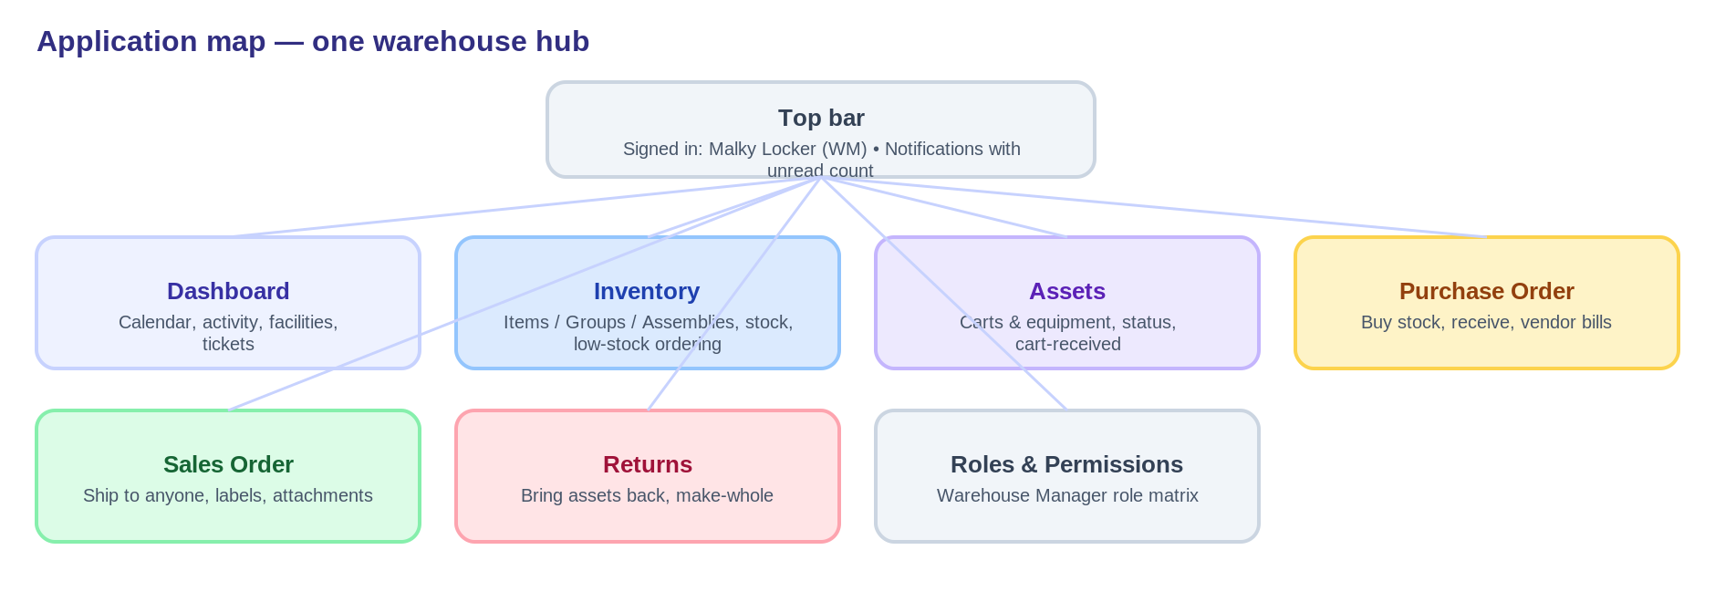
The seven sections and the top bar
Section | What it's for
Warehouse Dashboard | Home base: calendar, activity tracker, facilities, users, tickets.
Inventory | Items, Groups and Assemblies; stock; build carts; reorder low stock.
Assets | Carts and equipment; set status; confirm cart deliveries.
Purchase Order | Buy stock from vendors; receive; vendor bills.
Sales Order | Ship to a facility, regional, provider or employee; print labels.
Returns | Bring assets back and make returned carts whole.
Roles & Permissions | The Warehouse Manager role and its permissions.

2. Item types & the asset lifecycle
Every item is one of three kinds, and the app is careful about when something becomes a tracked “asset”.
- Single — one item (e.g. laptop, tablet, cable). It can be flagged a tracked asset; if so it becomes an asset when shipped out on its own.
- Group — a bundle ordered/shipped together; never an asset.
- Assembly — parts built into one tracked unit (a cart); it becomes an asset when assembled, and the parts leave inventory.
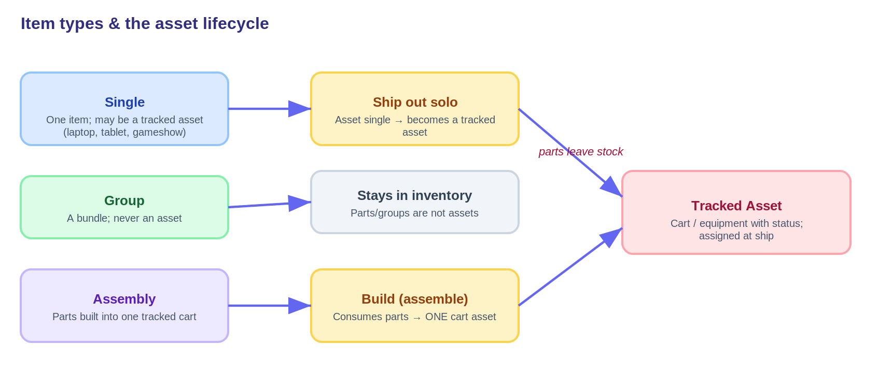
When an item becomes a tracked asset

3. Page-by-page tour

Warehouse Dashboard
The landing screen. The calendar sits on the left; the Activity Tracker and the cart-fulfillment guide sit on the right, so everything fits without scrolling. New calendar events are flagged with a red “!”.
- Calendar — onboarding dates, cart shipments, regional schedule and confirmed receipts.
- Facilities — fill in carts needed and the cart shipment date; manage notes, attachments and messages.
- Users & Tickets — the people directory and your tasks/tickets.
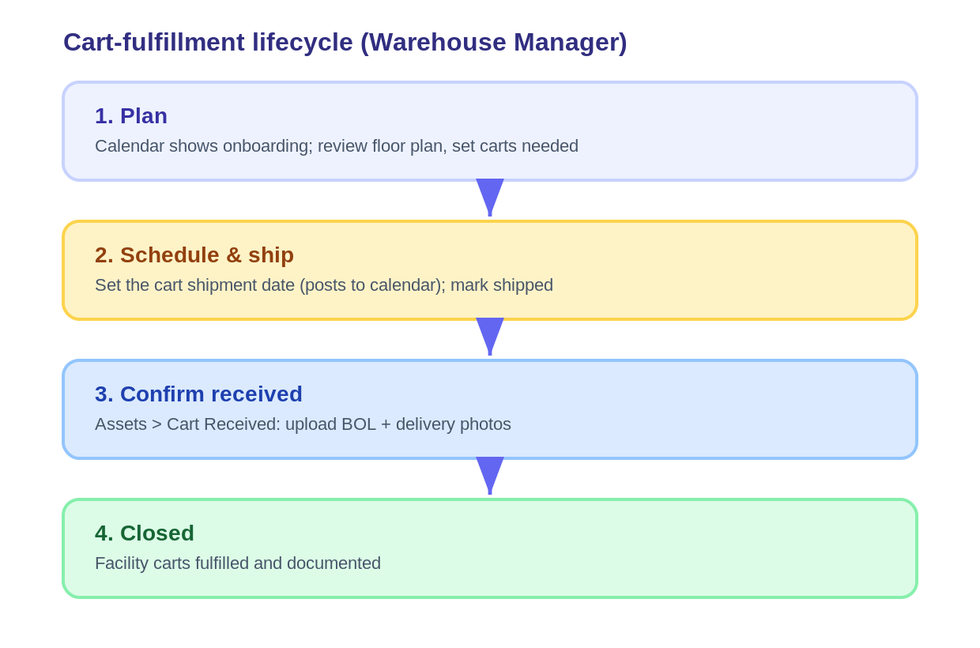
The cart-fulfillment lifecycle the dashboard drives

Inventory
One searchable list of Singles, Groups and Assemblies. Add any of the three kinds, adjust stock, view cost layers, and build carts. The column header stays pinned while you scroll.
- Click the Low-stock figure to see what's running out and order more in one click.
- Build an assembly: the cart's fields auto-fill, a Cart Code is required, and the parts are consumed into one cart asset.
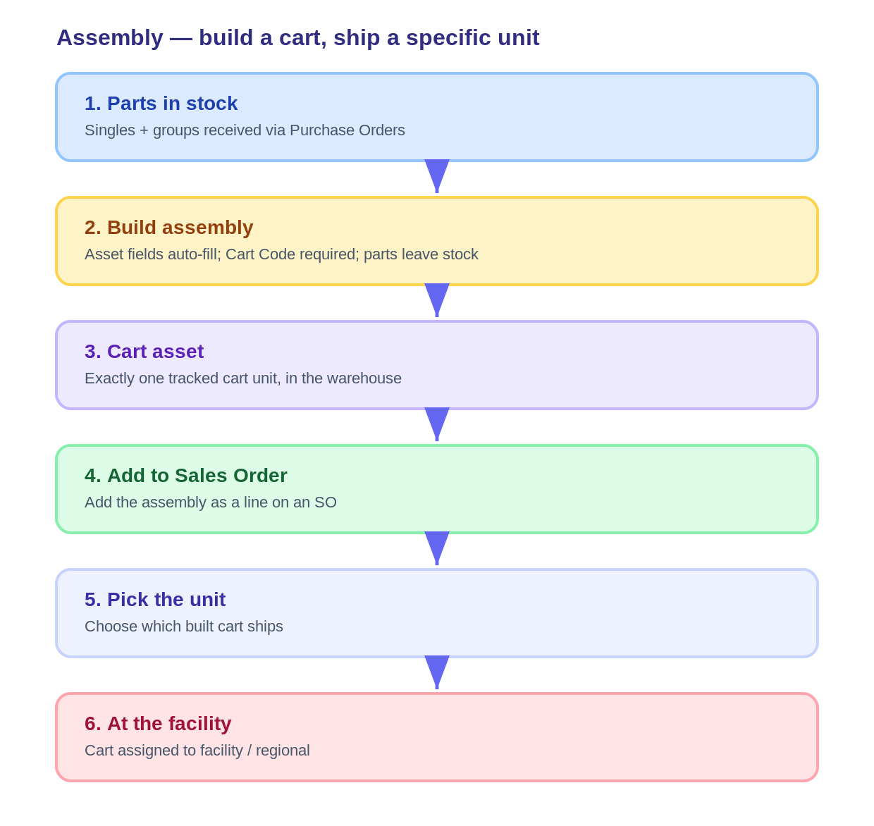
Building a cart and shipping a specific unit

Purchase Order
Buy stock from vendors and receive it into inventory. A group is one line that scales its members. Deposits auto-fill from the vendor, payments are editable, and receiving produces a Vendor Bill and shows the remaining balance.
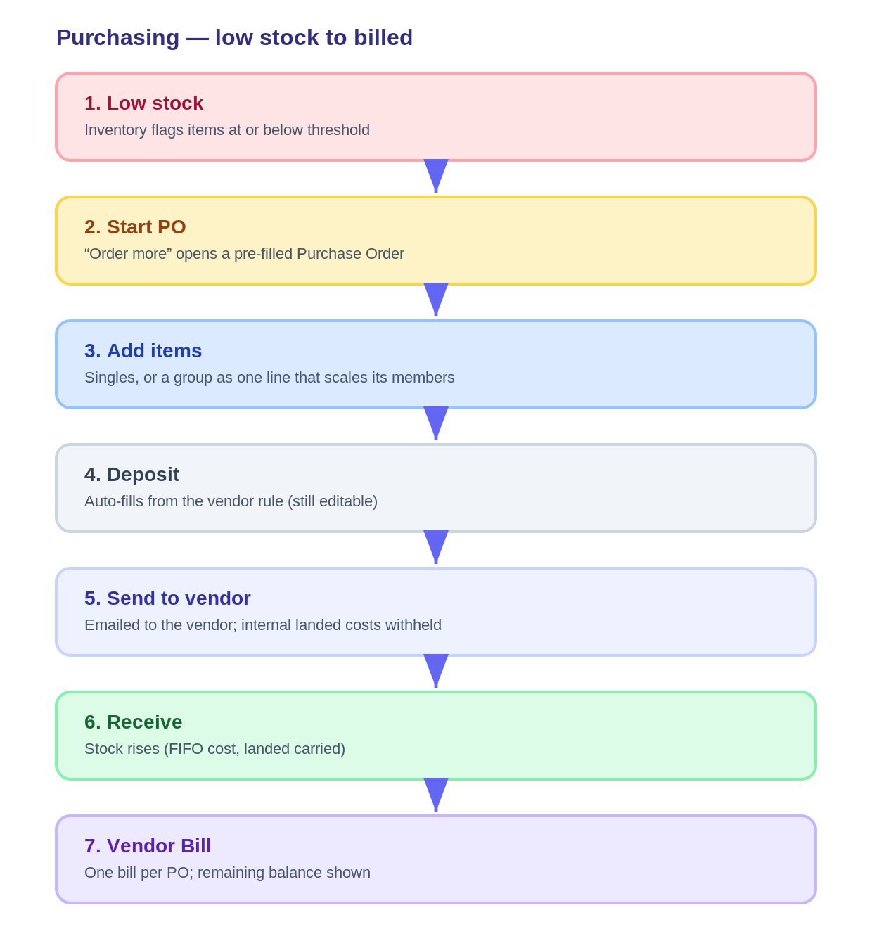
Purchasing — from low stock to received & billed

Sales Order
Send items to anyone. One search finds any recipient; the address line offers a Google-style lookup; a group adds as one scaling line; and an assembly lets you pick exactly which built cart ships. Short stock can create a back order, and you can print courier shipping labels.
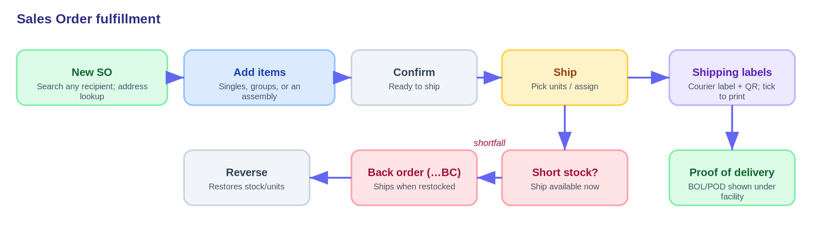
Sales Order fulfillment, including short-stock back orders

Assets
Carts, tracked equipment, and facility/user assets. The Warehouse Manager can change an item's status (e.g. Available, In repair, Returned, Retired) right from the page, and confirm cart deliveries by uploading a BOL and photos.

Returns
Only assets are returned. Start from a facility or an employee, confirm what arrived, refund the facility, and make a returned cart whole by replacing any missing parts from stock.
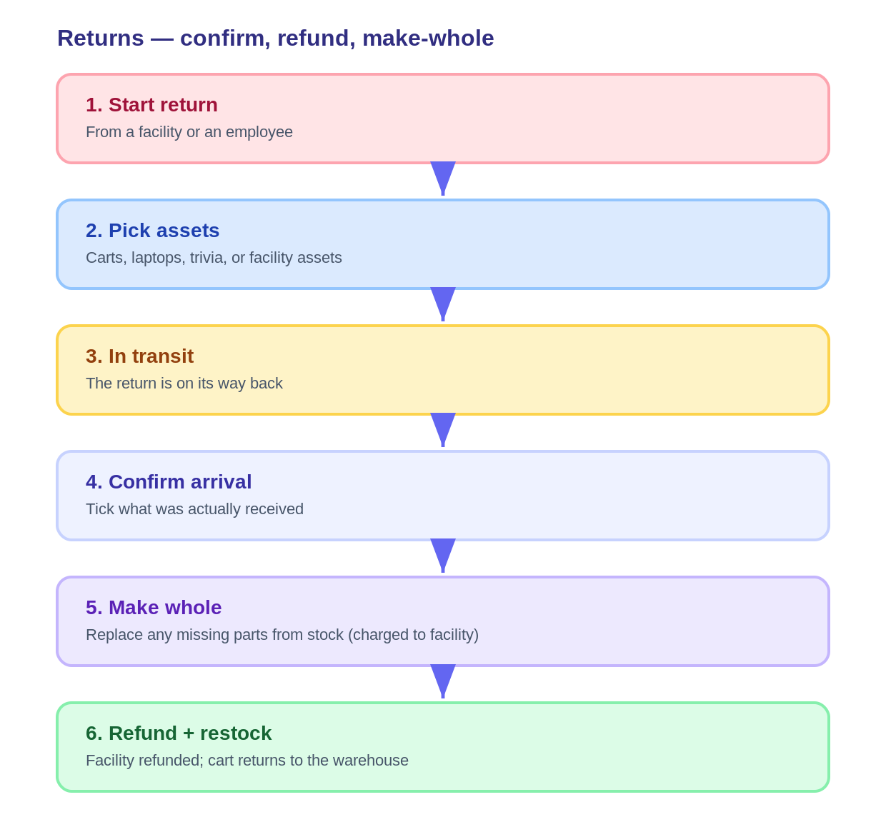
Returns — confirm, refund, make-whole

Roles & Permissions
Shows the purpose-built Warehouse Manager role and its line-by-line permissions, with the ability to derive a trimmed Warehouse Employee role and flag items still to confirm.

4. Features across every page
- Notifications — the top-bar bell lists alerts (low stock, deposits, shipments, returns, and more); mark read and jump to the related screen.
- Activity tracker — the dashboard shows recent warehouse activity with “new” flags.
- Viewable documents — click any floor plan, Bill of Lading or proof-of-delivery to open a realistic page and Print / Save as PDF.
- Courier shipping labels — real-style FedEx / UPS / USPS / Freight labels with scannable QR codes; tick which to print and search by name, facility, order or carrier.
- Vendor Bills — vendor billing is built in (no external accounting platform).
- Hands-on demo data — every page is pre-populated so the whole prototype can be explored end to end.

5. Quality check
The application's logic is verified by automated checks covering all pages and core functions — purchasing & receiving, sales & shipping, item types & assemblies, the asset lifecycle, and returns — all passing, with a clean production build. This report reflects the current, working state of the app.

Demo notes: changes live in the open browser tab and reset on close (or via “Reset demo data”). Address lookup uses OpenStreetMap in the demo and would use Google Maps in production. Shipping labels and tracking numbers are realistic mock data.

